

University of Asia Pacific
Course title: Software Engineering Lab
Course Code : CSE 314
Sohoj Biniyog

Team Members
Shahriar Alam Shimul 22201227
Salman Nur Ramim 22201239
Tahsin Sheikh 22201243

Submitted To :
Noor Mairukh Khan Arnob
Lecturer
Department of Computer Science & Engineering
University of Asia Pacific
1. Introduction
The Sohoj Biniyog project is designed to provide a Shariah-compliant investment and funding platform that connects small and medium-sized enterprises (SMEs) with potential investors. This system aims to create an easy, transparent, and secure environment where entrepreneurs can raise funds for their businesses while investors can explore safe and ethical investment opportunities. By integrating a modern backend with a responsive frontend, Sohoj Biniyog ensures seamless data flow, user-friendly navigation, and trustworthy financial interactions. This project demonstrates how technology can bridge the gap between SMEs seeking capital and individuals looking for sustainable, impactful investment options.
2. Objectives
The primary objectives of this project are:
• To develop a backend system using Django Framework for managing investment campaigns, user accounts, and transaction data.
• To build a frontend using HTML, CSS.
• To provide a simple and interactive interface for investors and SMEs to connect and manage funding activities.
• To establish a secure and Shariah-compliant platform that ensures transparency, trust, and accessibility in SME financing.
3. Project Overview
The project is divided into two main components:
Backend: Developed using Django Framework, the backend provides managing users, campaigns, investments, and related financial transactions. It also enforces business logic such as campaign funding limits, validation.
Frontend: Built using HTML, CSS. It allows users to browse campaigns, track investments, and manage accounts through an interactive interface.
The system architecture ensures a clear separation of concerns, where the backend handles data and logic, and the frontend focuses on presentation and user interaction.
4. Technologies Used
The project utilizes modern web development technologies, including:
• Backend: Django Framework
• Frontend: HTML
• Styling: Tailwind CSS for responsive and modern UI design
• Database: MySQL (for production) and SQLite (for development)
5. System Design
The system is designed to be modular, scalable, and secure. Key design considerations include:

• Database Design: Models are structured to store information about users, SMEs, campaigns, and investments efficiently. Relationships are established using foreign keys to maintain integrity and traceability of transactions.
• Frontend Design: Components are modular, reusable, and responsive. Data fetched from the backend is displayed dynamically, ensuring a seamless experience for investors and SMEs.
• Security: Role-based access control ensures that SMEs, investors, and admins have distinct permissions, protecting sensitive financial data.
6. Implementations
In the current stage of the project, the following has been implemented:
• Backend Setup: A Django project with models for users and campaigns has been created. Initial API endpoints return test data for integration checks.
• Frontend Setup: A Next.js application is configured to fetch data from the backend using Axios. The homepage displays campaigns and messages from the API to confirm successful integration.
• Navigation: A responsive navigation bar and footer have been implemented, allowing smooth transitions between pages such as Home, Funded Campaigns, About Us, and Contact.
Future implementation will focus on:
• Full CRUD operations for campaigns and investments
• Secure user authentication with role-based access (Investor, SME, Admin)
• Payment gateway integration (e.g., bKash/Nagad) for transactions
• Enhanced UI for campaign browsing, funding, and investor dashboards
• Detailed analytics and reporting for users and SMEs

7. Screenshot
Main Directory
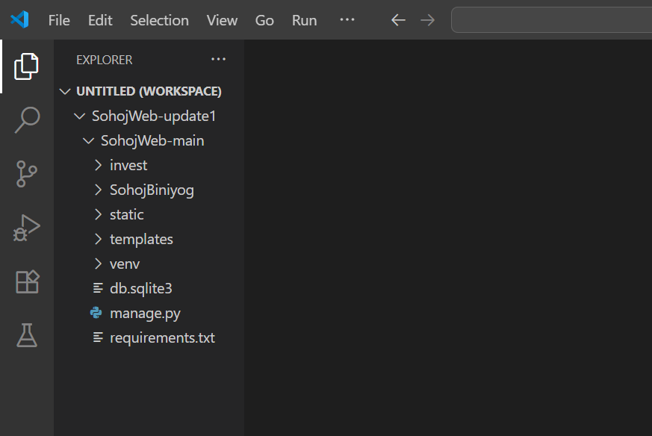
Django Settings
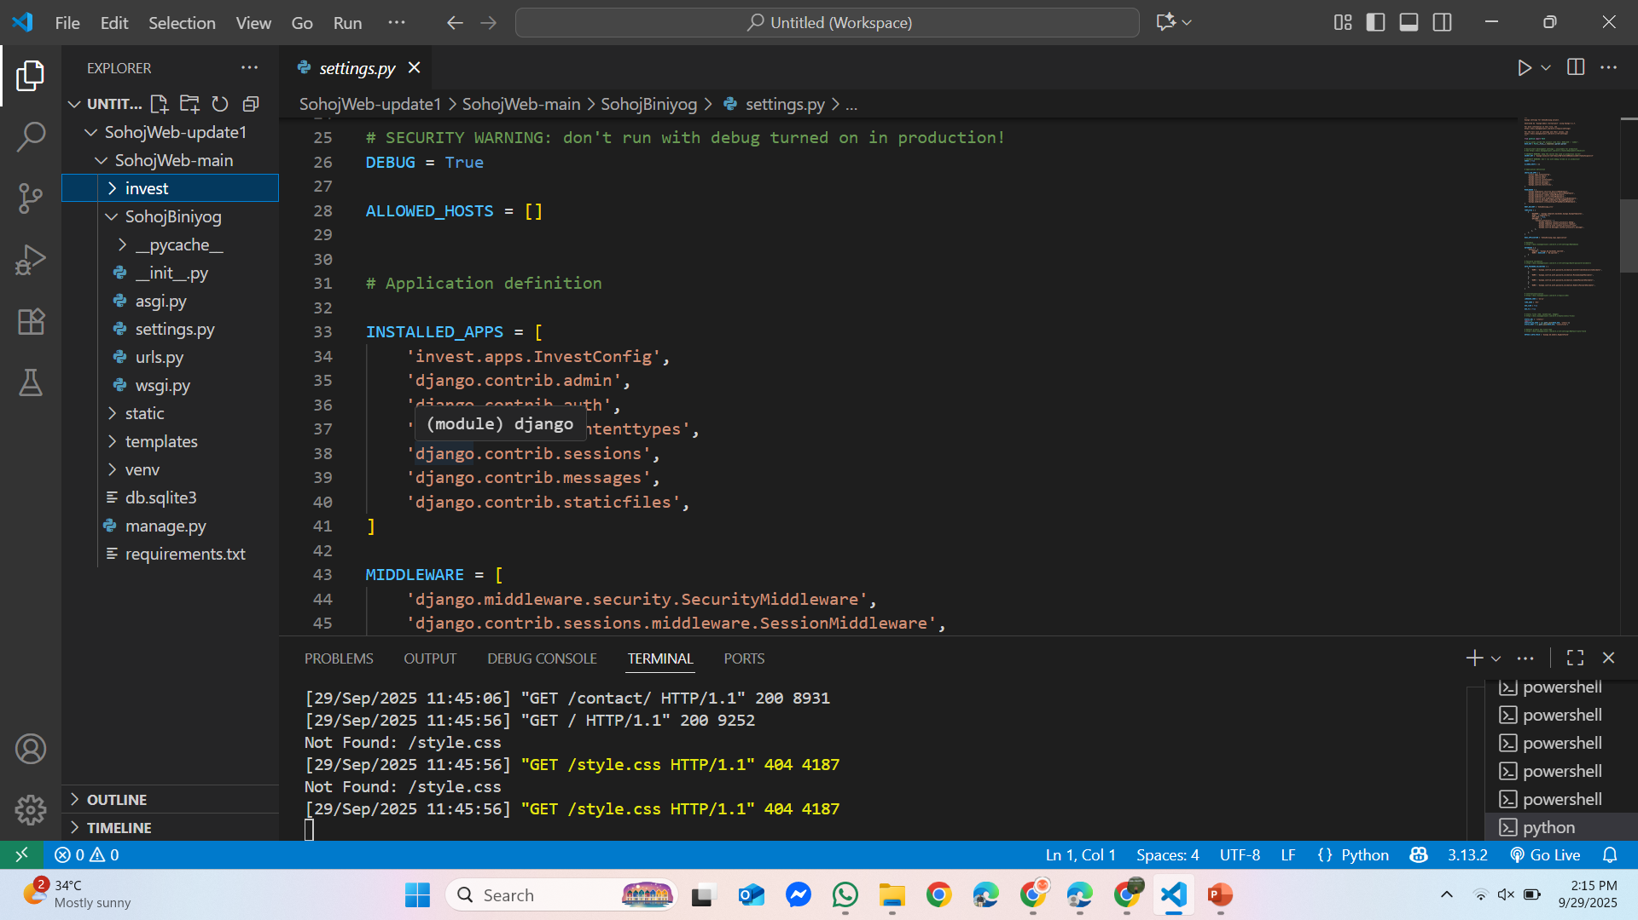

Django Urls
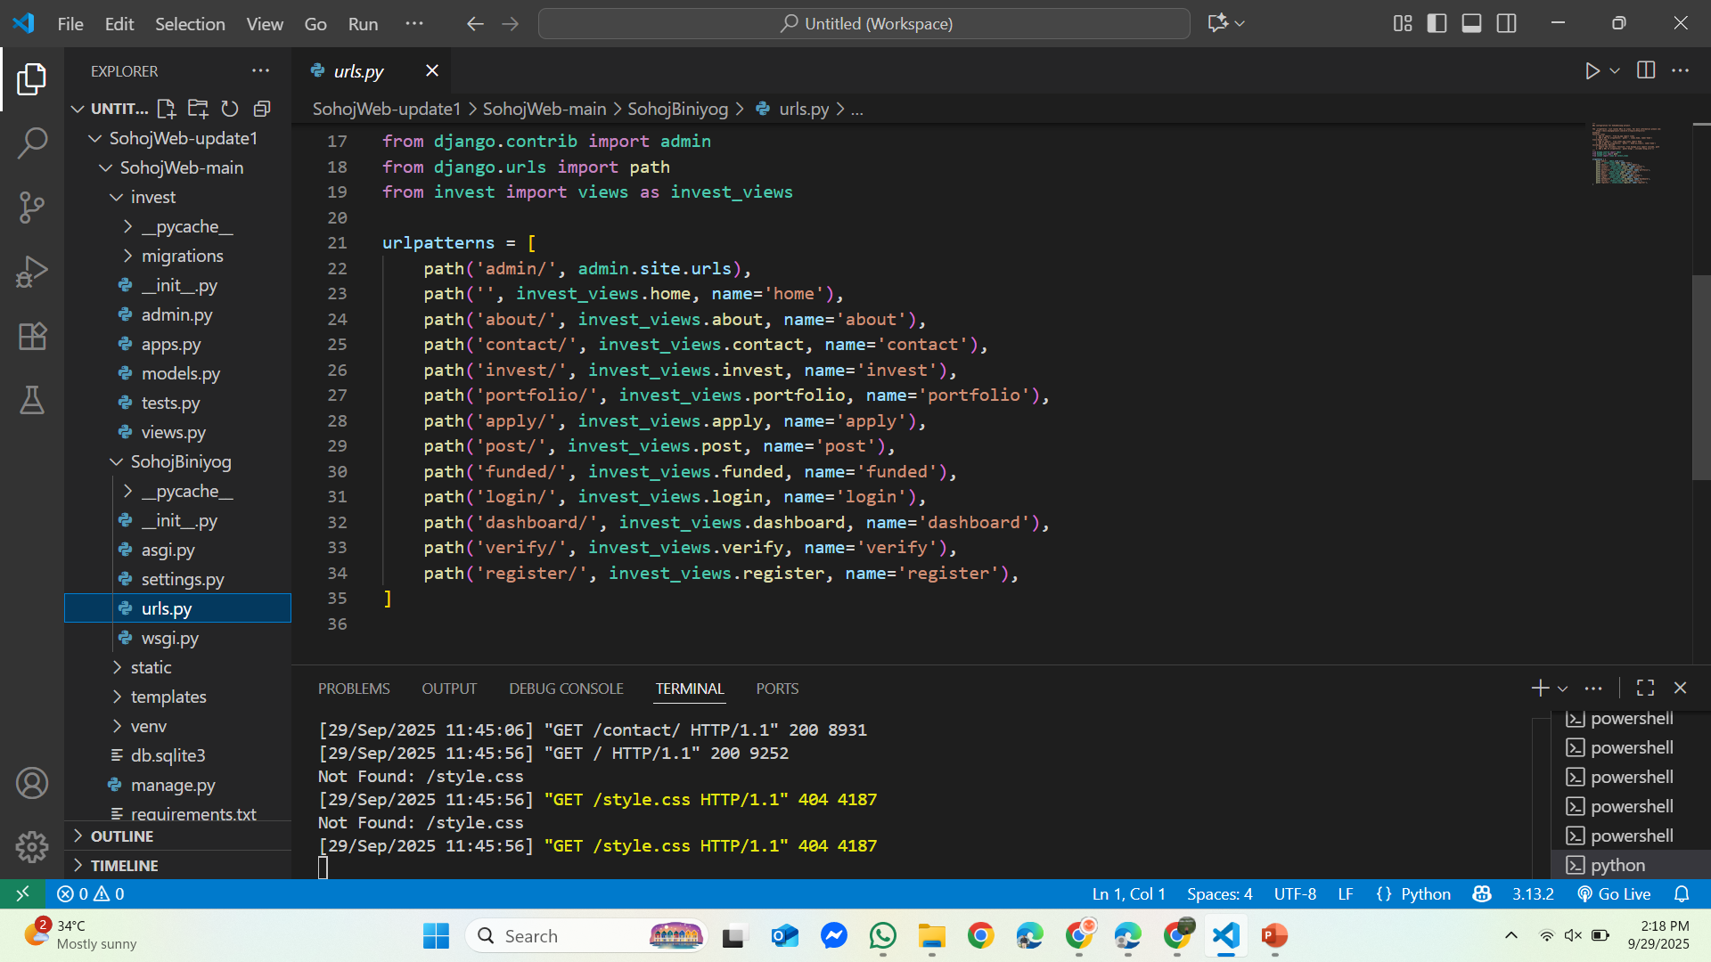
Django Views
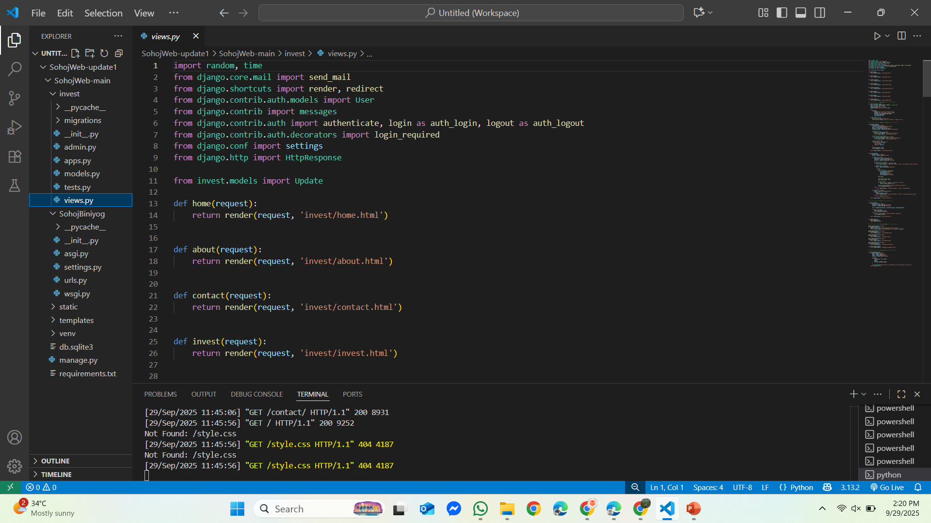

Django Models
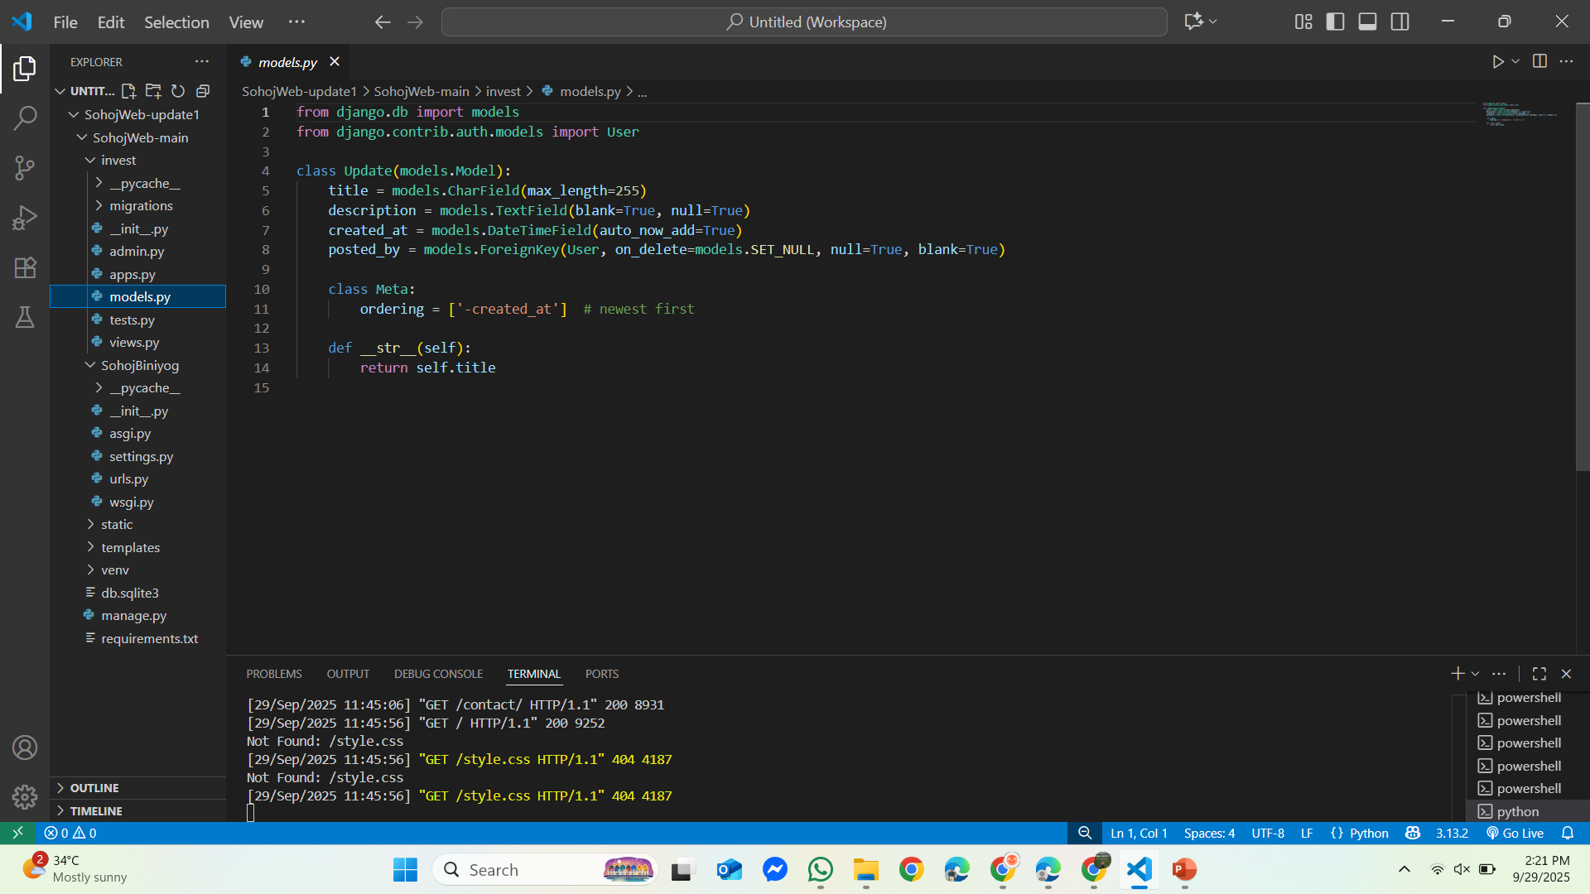
Home page
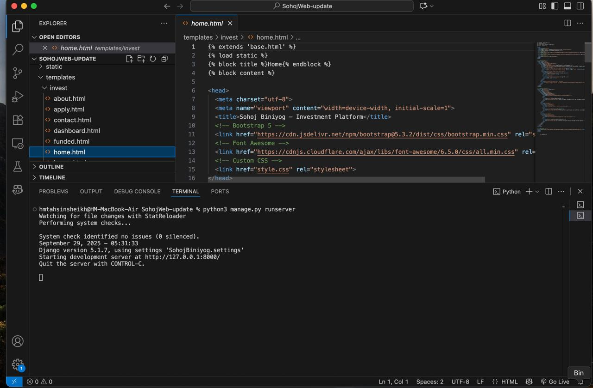

Register page
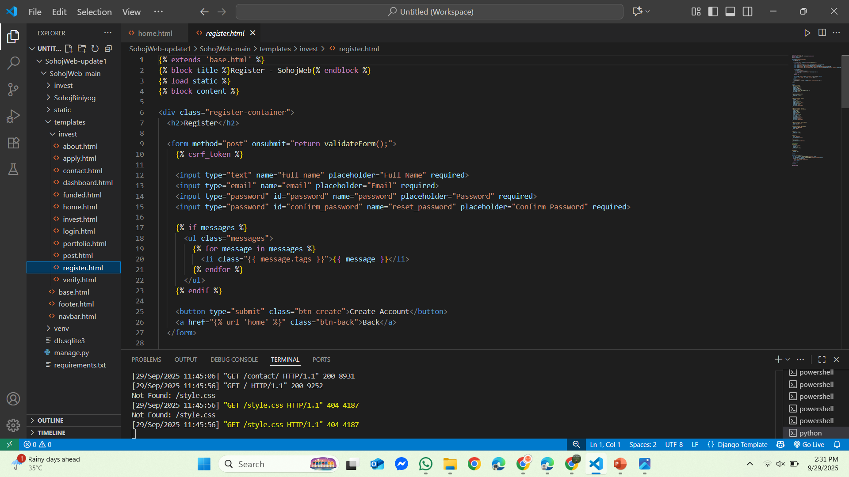
Log in page
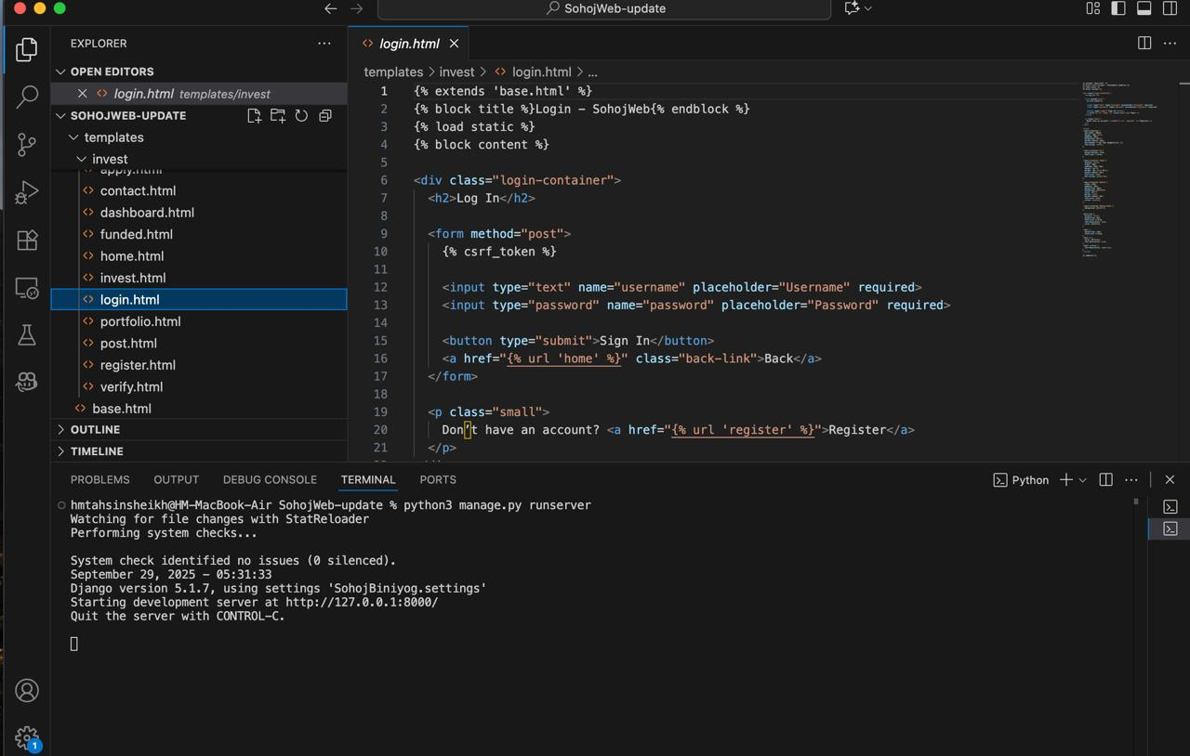
About page
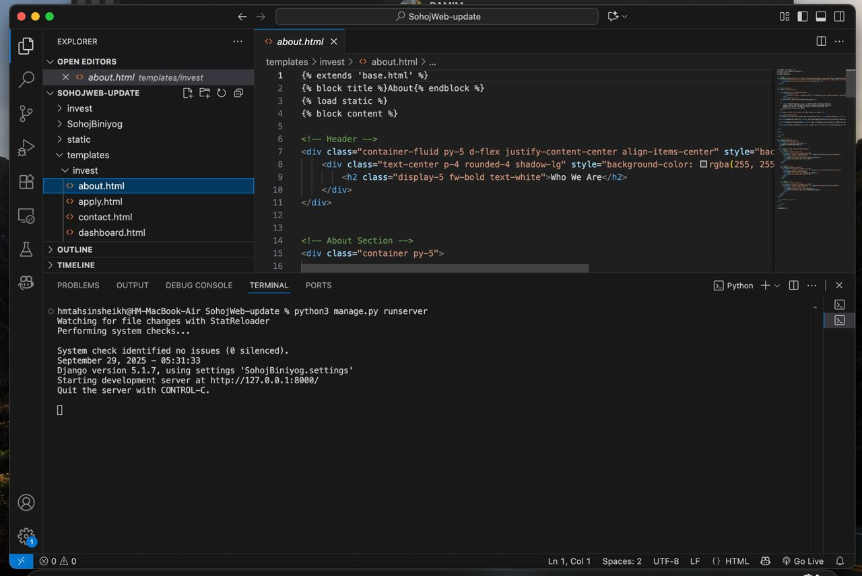
Contact page
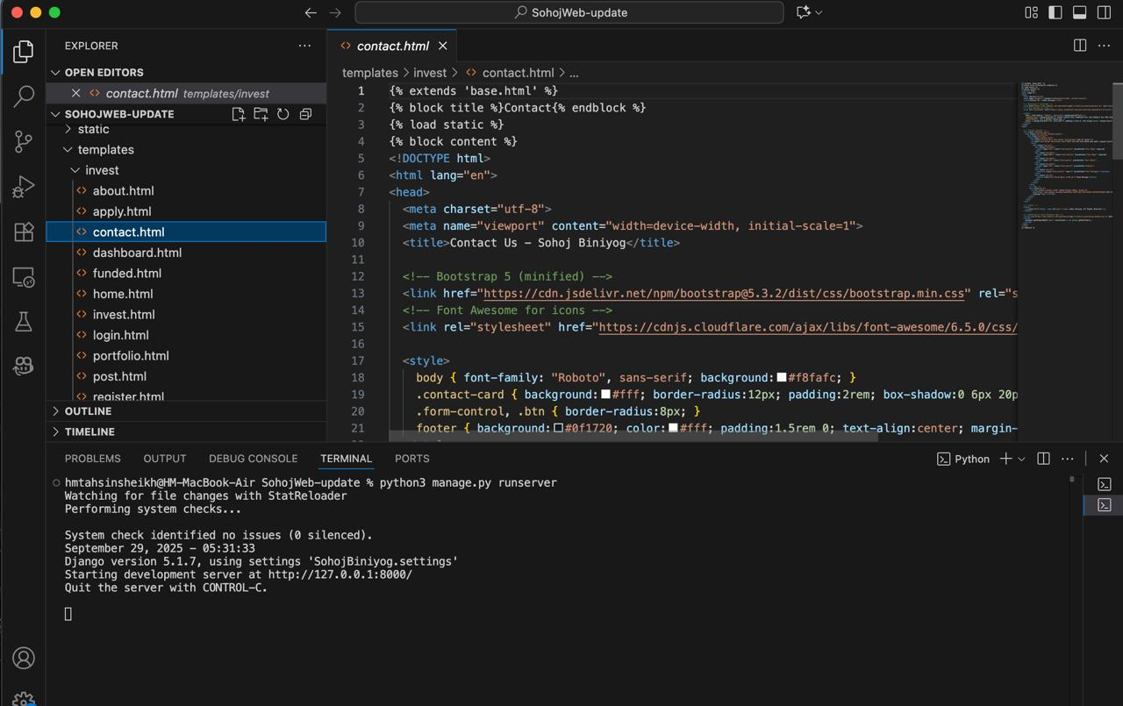
8. Github Repository
The project is hosted on GitHub for version control and collaboration:
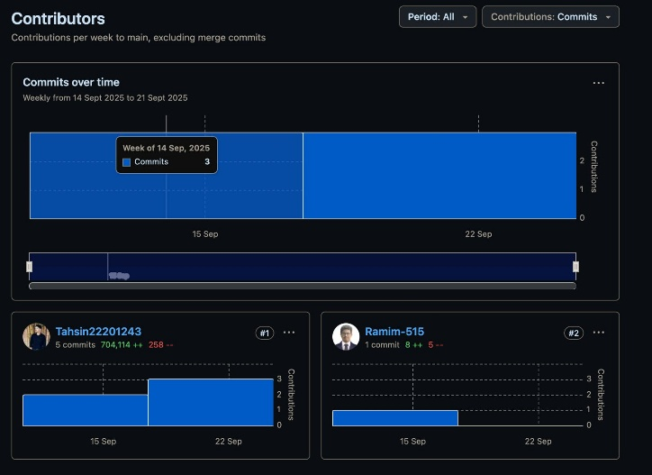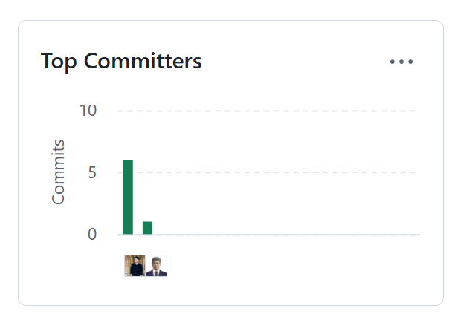
https://github.com/Tahsin22201243/SohojWeb
The repository includes both the backend and frontend code, along with project documentation and setup instructions.
9. Conclusion
This report outlines the initial phase of the Sohoj Biniyog project. The platform has successfully established the foundation for a Shariah-compliant investment system with a Django backend and HTML, CSS frontend. Core components such as backend setup, frontend integration, and basic navigation between pages have been implemented. Future enhancements will focus on enabling full campaign and investment management, secure authentication with role-based access, payment gateway integration, and a more interactive and user-friendly interface for investors and SMEs.

